**HALF ADDER**

**EXP NO: 15**

**AIM:** To design implement half adder using Logisim simulator.

**ALGORITHM:**

1. Connect the inputs to the x-or gate.
2. Connect those inputs to the AND gate.
3. Start the connections on the AND gate and finished it reaching the designated inputs.
4. Connect the outputs to the gates.
5. Check and verify the truth table accordingly.

**DIAGRAM:**

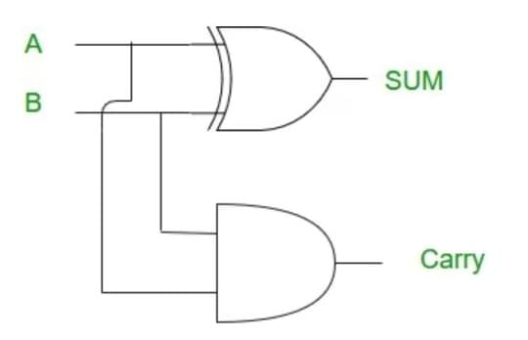

**TRUTH TABLE:**

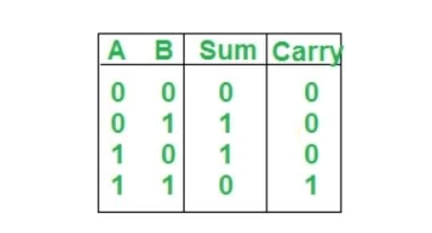

**OUTPUT:**

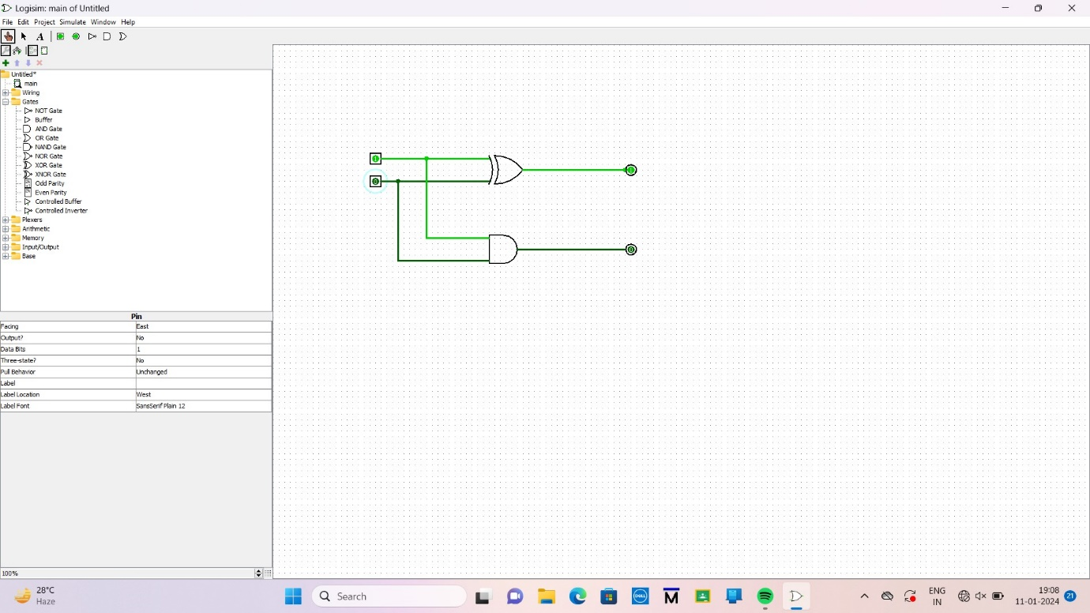

**RESULT:**  The implementation of half adder using Logisim simulator was executed successfully.